**Project Planning Phase**

**Prepare Milestone & Activity List**

**Project Planning Template (Product Backlog, Sprint Planning, Stories, Storypoints)**

|  |  |
| --- | --- |
| Date | 17 Nov 2022 |
| Team ID | PNT2022TMID50233 |
| Project Name | Project – WEB PHISHING DETECTION |
| Maximum Marks | 4 Marks |

**Product Backlog, Sprint Schedule, and Estimation (4 Marks)**

|  |  |  |  |  |  |  |
| --- | --- | --- | --- | --- | --- | --- |
| **Sprint** | **Functional**  **Requirement (Epic)** | **User Story Number** | **User Story / Task** | **Story Points** | **Priority** | **Team**  **Members** |
| Sprint-1 | User input | USN-1 | Userinputs an URL in the required field to check its validation. | 1 | Medium | Tejaswini.T |
| Sprint-1 | Website Comparison | USN-2 | Model compares the websites using Blacklist and Whitelist approach. | 1 | High | Blessy Sharon Rose.J |
| Sprint-2 | Feature Extraction | USN-3 | After comparison, if none found on comparison then  it extract feature using heuristic and visual similarity. | 2 | high | Sowmiya.R |
| Sprint-2 | Prediction | USN-4 | Model predicts the URL using Machine learning algorithms such as logistic Regression, KNN. | 1 | Medium | Valarmathi.C |
| Sprint-3 | Classifier | USN-5 | Model sends all the output to the classifier and produces the final result. | 1 | Medium | Subbulakshmi.P |
| Sprint-4 | Announcement | USN-6 | Model then displays whether the website is legal site or a phishing site. | 1 | High | Tejaswini.T |
| Sprint-4 | Events | USN-7 | This model needs the capability of retrieving and displaying accurate result for a website. | 1 | High | Blessy Sharon Rose.J |

**Project Tracker, Velocity & Burndown Chart: (4 Marks)**

|  |  |  |  |  |  |  |
| --- | --- | --- | --- | --- | --- | --- |
| **Sprint** | **Total Story Points** | **Duration** | **Sprint Start Date** | **Sprint End Date (Planned)** | **Story Points**  **Completed (as on**  **Planned End Date)** | **Sprint Release Date (Actual)** |
| Sprint-1 | 20 | 6 Days | 24 Oct 2022 | 29 Oct 2022 | 20 | 29 Oct 2022 |
| Sprint-2 | 20 | 6 Days | 31 Oct 2022 | 05 Nov 2022 | 20 | 05 Nov 2022 |
| Sprint-3 | 20 | 6 Days | 07 Nov 2022 | 12 Nov 2022 | 20 | 12 Nov 2022 |
| Sprint-4 | 20 | 6 Days | 14 Nov 2022 | 19 Nov 2022 | 20 | 19 Nov 2022 |
|  |  |  |  |  |  |  |
|  |  |  |  |  |  |  |
|  |  |  |  |  |  |  |
|  |  |  |  |  |  |  |

**Velocity:**

Imagine we have a 10-day sprint duration, and the velocity of the team is 20 (points per sprint). Let’s calculate the team’s average velocity (AV) per iteration unit (story points per day)

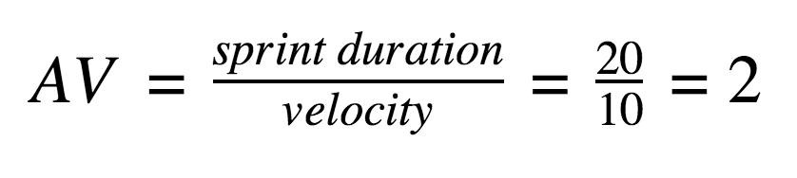

**Burndown Chart:**

A burn down chart is a graphical representation of work left to do versus time. It is often used in agile software development methodologies such as Scrum. However, burn down charts can be applied to any project containing measurable progress over time.

**https://www.visual-paradigm.com/scrum/scrum-burndown-chart/ https://www.atlassian.com/agile/tutorials/burndown-charts**

**Reference: https://www.atlassian.com/agile/project-management https://www.atlassian.com/agile/tutorials/how-to-do-scrum-with-jira-software https://www.atlassian.com/agile/tutorials/epics https://www.atlassian.com/agile/tutorials/sprints https://www.atlassian.com/agile/project-management/estimation https://www.atlassian.com/agile/tutorials/burndown-charts**